|  |  |
| --- | --- |
|  | **Year 11 ATAR Human Biology**  **Task 12 – Genetics & Inheritance** |

|  |  |  |  |
| --- | --- | --- | --- |
| **Name: Marking Key** | **Teacher:** | **Date:** | **Score: /70** |

**Assessment type:** Test

**Conditions**

Time for the task: 55 minutes

**Task weighting** - 9%

Total marks: 70

___________________________________________________________________________

**Section 1: Multiple-choice (12 marks)**

This section has 10 questions. Answer all questions by circling the correct answer.

1. Factors that control traits are called:
   1. genes.
   2. homozygous.
   3. recessives.
   4. dominants.
2. What do the letters TT mean to geneticists?
   1. Two recessive genes.
   2. At least one dominant allele.
   3. One dominant and one recessive allele.
   4. Two dominant alleles.
3. Which of the following are true in relation to the ABO blood group system?
   1. An individual may possess two of the three alleles.
   2. Allele IA and IB are co-dominant.
   3. When neither Antigen A or B is present, group O blood is produced.
   4. All of the above.
4. Sex-linked traits are more common in males than in females because:
   1. all alleles on the X chromosome are dominant.
   2. all alleles on the Y chromosome are recessive.
   3. a recessive allele on the X chromosome will always produce the trait in a male.
   4. any allele on the Y chromosome will be co-dominant with the matching allele on the X chromosome.
5. Geneticists use pedigree charts to:
   1. calculate genetic crosses.
   2. to replicate identical strings of DNA.
   3. to trace the inheritance of traits over generations of families.
   4. to prove that sex-linked traits are caused by co-dominant alleles.
6. In humans, colour blindness is an X-linked recessive condition. If a normal man has a child with a woman who is a carrier for the condition of colour blindness, what is the chance that one of their children will be born colour blind?
   1. 0.25
   2. 0.50
   3. 0.75
   4. 1.0
7. Sex-linked genes are genes on:
   1. the X chromosome only.
   2. the Y chromosome only.
   3. the X or Y chromosomes.
   4. all 23 pairs of chromosomes.
8. A person who is heterozygous has:
   1. two recessive alleles for a trait.
   2. one recessive and one dominant allele for a trait.
   3. more than two alleles for a trait.
   4. two dominant alleles for a trait.
9. ___________________ states that the two alleles of a gene found on each of a pair of chromosomes separate independently of one another into sex cells.
   1. Mendel’s principle of segregation.
   2. Mendel’s principle of random inheritance.
   3. Mendel’s principle of common descent.
   4. Mendel’s principle of independent assortment.
10. The physical appearance of an individual is referred to as:
    1. pure-breeding.
    2. the genotype.
    3. hybridisation.
    4. the phenotype.
11. Co-dominance in genetics means:
    1. both alleles are dominant.
    2. both alleles are recessive.
    3. the alleles are neither dominant nor recessive.
    4. each allele is both dominant and recessive.
12. A female carrier for the recessive condition (Duchenne Muscular dystrophy) would have which of the following genotype?
13. XRY
14. XrY
15. XRXr
16. XrXr

**Section 2: Short answer (48 marks)**

This section has three questions. Answer all questions. Write your answers in the spaces provided.

1. Use the diagram below to answer the following questions.

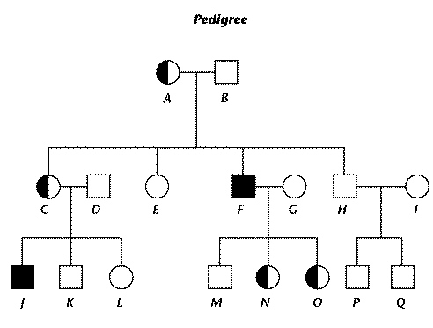

1. What do the circles in the pedigree represent? _____Females______________________(1 mark)
2. What do the squares represent? _______Males________________________(1 mark)
3. Which pairs of individuals in the pedigree have children? _A&B, C&D, F&G, H&I________(1 mark)
4. Which individuals in the pedigree have the trait that is traced in the pedigree? _F&J______(1 mark)
5. Cystic fibrosis (CF) is an autosomal recessive disorder. A couple with a history of CF in their families undergo genetic counselling before trying to conceive a baby.
6. It is found that the man is a carrier for CF and the woman is homozygous normal. With the use of a Punnett square, predict the possible genotypes and phenotypes of their future children.

|  |  |  |
| --- | --- | --- |
|  | F | F |
| F | FF | FF |
| f | Ff | Ff |

(1)

Genotypes: FF 50%, Ff 50% (1)

Phenotypes: Normal (No Cystic fibrosis) 100% (1)

(3 marks)

1. What is the probability of this couple having a child with Cystic Fibrosis? ______0%_____________

(1 mark)

1. Hypercholesterolemia is a rare disorder in humans that causes high cholesterol due to lowered numbers of low density lipoprotein (LDL) receptors. Base your answers to the following questions on the pedigree below, which shows the presence of Hypercholesterolemia in a family.

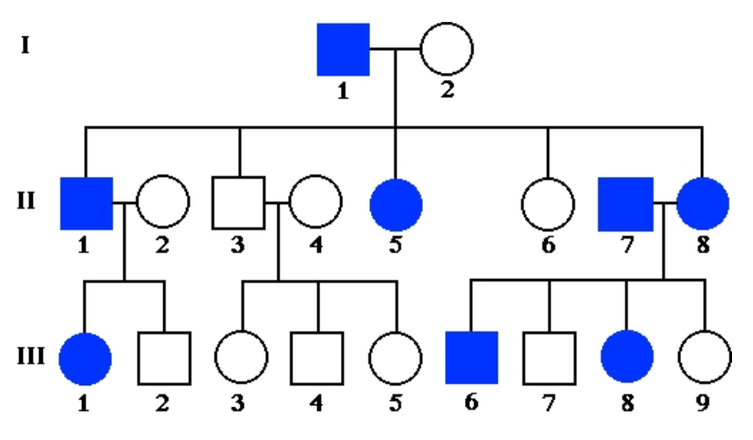

1. What is the most likely mode of inheritance for this trait? Justify your answer.

autosomal dominant (1), appears in every generation (1), equal numbers of males & females (1)

(3 marks)

1. Write the genotypes for all individuals in generation III under their corresponding numbers on the pedigree.

1-Hh (1), 2-hh (1), 3-hh, 4-hh, 5-hh, 6-HH or Hh(1), 7-hh, 8-HH or Hh (1), 9-hh (2,3,4,5,7&9 = 1 mark (4 marks)

1. Long eyelashes are dominant over short eyelashes. A mother with long eyelashes, whose father had short eyelashes, is expecting a child with her partner who is heterozygous for long eyelashes. What are the possible genotypes and phenotypes for their offspring?

|  |  |  |
| --- | --- | --- |
|  | E | e |
| E | EE | Ee |
| e | Ee | ee |

Genotypes: EE – 25%

Ee – 50% (1)

ee – 25%

Phenotypes: 75% long eyelashes

25% short eyelashes (1)

1 mark each for correct parent genotypes

(4 marks)

1. Describe the difference between:
   1. homozygous and heterozygous. ____having two dominant or recessive alleles Vs having one dominant and one recessive allele________________________________________
   2. genotype and phenotype ____letters representing the alleles for a trait of an individual Vs physical appearance of an individual for a trait_________________________________
   3. dominant and recessive___characteristic or trait that will always be expressed Vs characteristic or trait that can be masked by a dominant trait_______________________________
   4. autosomal and sex-linked ___gene is located on an autosomal chromosome (1-22) Vs gene is located on sex-chromosome (23)_____________________

(4 marks)

1. Use the pedigree below to answer the following questions.

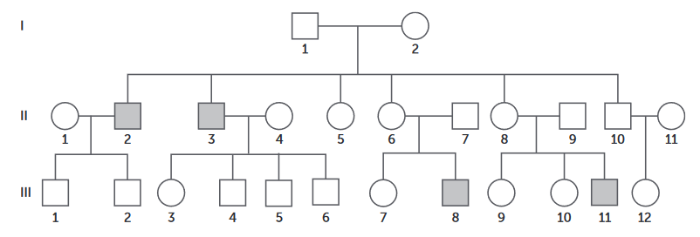

1. Identify the mode of inheritance for the pedigree above. Justify your answer.

__________Sex-linked recessive (1,) not present in every generation (1), only affects males (1)

(3 marks)

1. identify the genotype/s of the following individuals:
   1. I-2 ___XDXd___________
   2. II-3 ___XdY___________
   3. II-6 ___XDXd_____
   4. III-3 ___XDXd___________ (4 marks)
2. Although a rare occurrence, cases of babies switched at birth in a hospital have made the news in the past. Below is the result of a DNA fingerprint conducted on three babies and three sets of parents to determine which baby belongs to which parent.

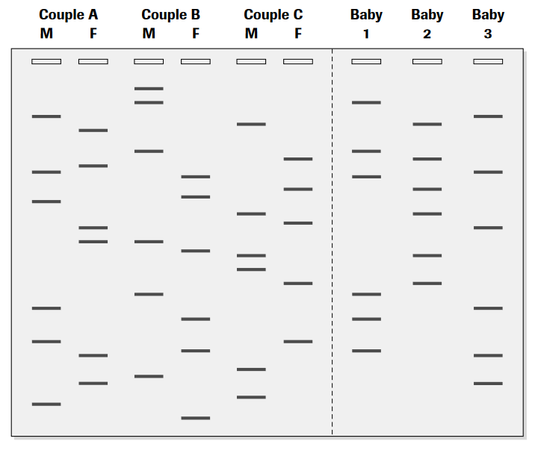

Longest

Shortest

* 1. Identify the longest and the shortest DNA fragments on the gel by circling them on the diagram.

(2 marks)

* 1. Identify which baby belongs to which set of parents.

Couple A: ___3___________________________

Couple B: ___1___________________________

Coupe C: ____2__________________________ (3 marks)

1. A newborn baby required a blood transfusion and the parents were shocked to find out that their child had a different blood type. They begin to question how this is possible. The mother has blood type O, the father has blood type AB and the baby has blood type B. Explain, using a Punnett square, how it is possible for the baby to have this blood type.

|  |  |  |
| --- | --- | --- |
|  | i | i |
| IA | IAi | IAi |
| IB | IBi | IBi |

Correct genotypes for parents (1)

Correct crossing on Punnett Square (1)

Principle of Segregation – alleles inherited separately (1)

Genotypes: IAi – 50% and IBi – 50% (1)

Phenotypes: Blood Group A – 50% and Blood Group B – 50% (1)

*any 4 for one mark each*

(4 marks)

1. A colour-blind father is preparing to welcome a child with his partner who has normal vision. What is the chance of them having:
2. a child with normal vision? ___100%_________________________________________________
3. a colour-blind daughter? _____0%_________________________________________________
4. a son with normal vision? ____100%_________________________________________________

(3 marks)

1. Huntington’s disease is a brain disorder resulting in mental disturbances, clumsiness, depression and forgetfulness. Symptoms usually begin to show at around the age of 40, with a life expectancy of a further 30 years. The pedigree below is for a family that has a history of Huntington’s disease.



1. Huntington’s Disease is a dominant allele. Is it autosomal or X-linked?

_____________autosomal____________________________________________________________

(1 mark)

1. What evidence do you have to support your answer to b)?

__________________________________________________________________________________

(1 mark)

1. If H is the allele for Huntingtons Disease:
   1. What is the genotype of individual I-2? ______hh_________________
   2. What is the genotype of individual II-8? ______Hh_________________
   3. What is the gender of individual II-7? ______male_________________
   4. What is the phenotype of individual III-1? ______Has Huntingtons_______ (4 marks)

**Section 3: Extended answer (10 marks)**

This section has one question. Write your answers in the spaces provided.

______________________________________________________________________________

**Question 20**

Genetic profiling and its applications raise many ethical and social issues. Ethics is the set of moral principles or values that are held by the majority of Australian society. In a large number of instances, when patients receive the results of genetic tests, they are party to information that directly concerns their biological relatives as well. Discuss the ethical issues to be considered by all parties involved in genetic testing.

Confidentiality

Informed consent

Right ‘not to know

Costs

Access to counselling

Who has access

_____________________________________________________________________________

__________________________________________________________________________________

__________________________________________________________________________________

__________________________________________________________________________________

__________________________________________________________________________________

__________________________________________________________________________________

__________________________________________________________________________________

__________________________________________________________________________________

__________________________________________________________________________________

__________________________________________________________________________________

__________________________________________________________________________________

__________________________________________________________________________________

__________________________________________________________________________________

__________________________________________________________________________________

__________________________________________________________________________________

__________________________________________________________________________________

__________________________________________________________________________________

__________________________________________________________________________________

__________________________________________________________________________________

__________________________________________________________________________________

__________________________________________________________________________________

__________________________________________________________________________________

__________________________________________________________________________________

__________________________________________________________________________________

__________________________________________________________________________________

__________________________________________________________________________________

__________________________________________________________________________________

__________________________________________________________________________________

__________________________________________________________________________________

__________________________________________________________________________________

__________________________________________________________________________________

__________________________________________________________________________________

__________________________________________________________________________________

__________________________________________________________________________________

__________________________________________________________________________________

__________________________________________________________________________________

__________________________________________________________________________________

__________________________________________________________________________________

__________________________________________________________________________________

__________________________________________________________________________________

__________________________________________________________________________________

__________________________________________________________________________________

__________________________________________________________________________________

__________________________________________________________________________________

__________________________________________________________________________________

__________________________________________________________________________________

__________________________________________________________________________________

**END OF TEST**